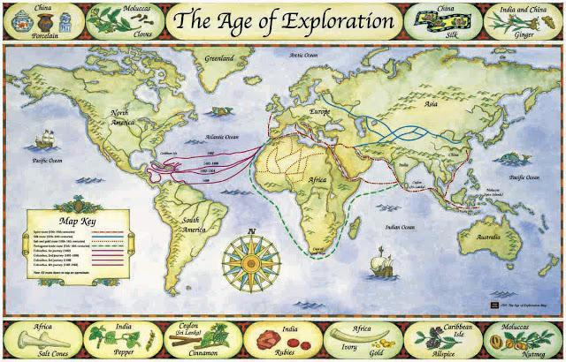
Age of Exploration Brochure
Course Competencies
- Turning Point/Change: What are the outcomes of the Age of Exploration, intended and unintended that led to changes in World History?
Topic: The Smithsonian is celebrating the 300th anniversary of the Age of Discovery by creating brochures for visitors. These brochures highlight some of the important aspects that played a critical role in Exploration. YOU have been chosen to create one of these brochures as a well-respected historian!

Assignment: Create a brochure that highlights the various factors of the Age of Exploration.
- Cover represents the Age of Exploration
- Should include a visual(s) and general information about exploration
- Inside Panel: Explorer
- Select an explorer and describe what country he sailed for, the route he took, what he discovered and the outcomes of his exploration.
- Provide a visual for the explorer/exploration
- Middle Panel: Menu
- Create a Restaurant and menu (Feel free to come up with a name for your restaurant)
- Choose to base your menu off of either goods that were new to the “New World” or new to the “Old World”
- Include items that could be served for breakfast, lunch and dinner.
- Right Panel: Destruction of Civilizations
- Create a memorial either for the Aztecs or Incas
- Examples: Headstone, ancient monuments, reflection on the civilization (speech)
- Include appropriate visuals and how civilization was destroyed
- Fold over Panel: Advertisement
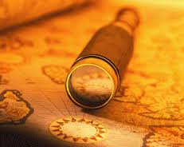
- Create an advertisement for a navigational instrument that allowed exploration to flourish during this time period
- Think about what elements advertisements include
- Try to convince a customer to purchase this instrument
- Back Panel: Gift Shop
- Include two items that could be purchased in the gift shop that would reflect the motives of the Age of Exploration
- Each item needs to be on display for the customer to view
Materials to use:
- Class Notes
- Class Readings
- Gallery Walk Activity
- Textbook pages 192-212

